Vacant Street Trading Sites

Oxford City Council is inviting applications for two vacant street trading sites, both in prime City Centre locations. The consent period for each pitch will be for 12 months.

The current vacant sites are:

Street Trading Site 14 outside Christ Church, St Aldate’s, Oxford – Trading hours 18:30 – 03:00 (subject to obtaining a premises licence under the Licensing Act 2003).

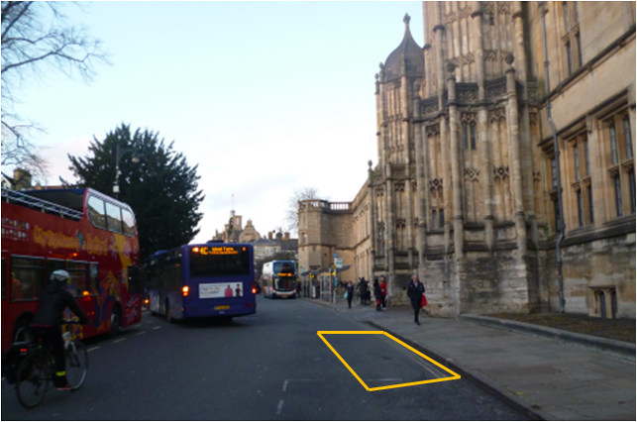

Street Trading Site 10 outside 22 High St (North Side), Oxford - Trading hours 18:30 – 03:00 (subject to obtaining a premises licence under the Licensing Act 2003).

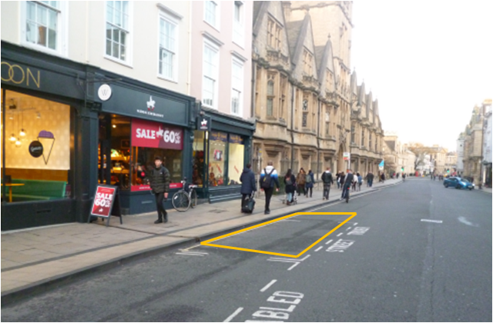

We are keen to encourage a wide range of food and drink in the City, so particularly welcome businesses who offer foods currently under-represented elsewhere. We also welcome new and innovative businesses and street trading vehicles that have a smart appearance and will fit in with the surrounding area.
If you would like to apply for either of the vacant street trading sites, please complete the application form by using the below link and return it with all supporting documents by email to street_trading@oxford.gov.uk or by post addressed to the Business Regulation Team, 109-113 St Aldate’s Chambers, St Aldate’s, Oxford OX1 1DS.

The closing date for receipt of applications is: 17:00 on Monday 17th February 2020

Please make sure before submitting an application you read the Council’s Street Trading Policy and Conditions of Street Trading Consent before submitting an application. Links to both documents can be found below.

We advise that you do not make any financial commitments before being granted Street Trading Consent in Oxford. For example, do not purchase a street trading vehicle/stall as there is no guarantee your application will be successful.

Once an application has been received and checked we will write to you confirming receipt of a valid application. If an application is not valid we will explain why and give you the opportunity to amend it and re-submit provided there is time before the closing date. Please note that any incomplete applications received will be returned to the applicant unprocessed and no fee will be incurred. The application fee is non-refundable; refunds will not be provided to unsuccessful applicants.

Applications that meet the criteria outlined in the Street Trading Policy will be referred to the Council’s General Purposes Licensing Casework Sub-Committee (which consists of a panel of Councillors and Council Officers) for determination.

Link to Application Form
Link to Policy and Conditions
Link to Fees & Charges

For further information or to discuss your street trading application, please contact the Business Regulation Team using the below details.

Business Regulation Team
Telephone: 01865 252561
Email: street_trading@oxford.gov.uk

Please note that applications will be included in a publicly available agenda (contact details will be removed).

